Copyright for test papers and marking guides remains with *West Australian Test Papers.*

Test papers may only be reproduced within the purchasing school according to the advertised Conditions of Sale.

Test papers should be withdrawn after use and stored securely in the school until 14th October 2019.



**MATHEMATICS**

**METHODS**

**UNITS 3 & 4**

**Semester Two**

**2019**

**SOLUTIONS**

***Calculator−free Solutions***

1. (a) 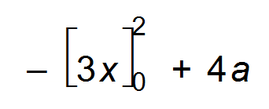 ✓

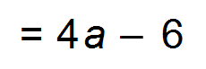 ✓

(b) 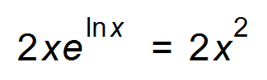 ✓

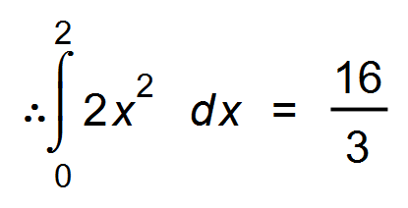 ✓ [4]

2. (a) 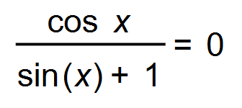 (where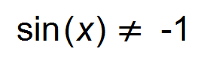 therefore 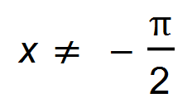 ) ✓

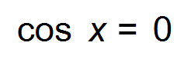

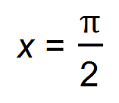 ✓

Stationary point at ( 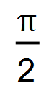 , ln 2 ) ✓

(b) 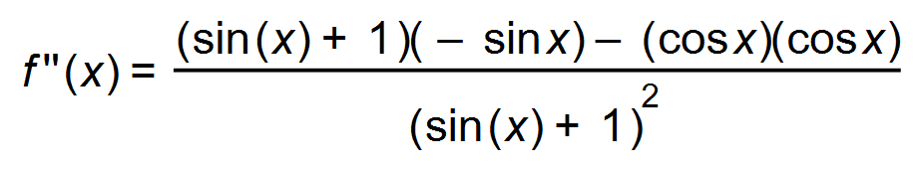 ✓

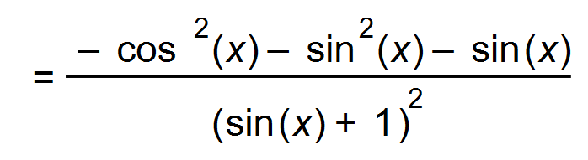 |  ✓

=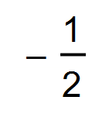 therefore maximum turning point. ✓ [6]

3. 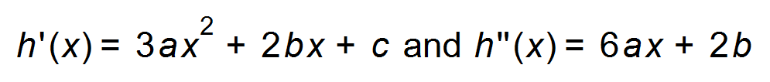 ✓

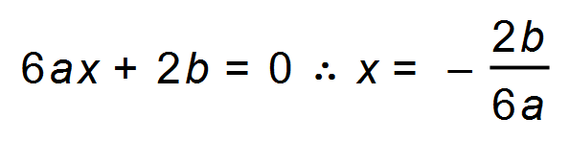 ✓

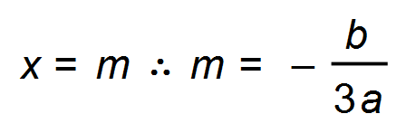 ✓ [3]

4. (a) (i) 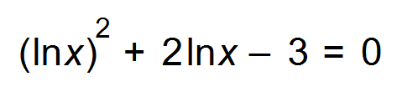

Let ln *x =m*

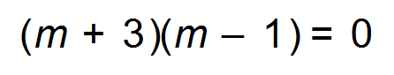 ✓

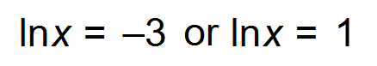 ✓

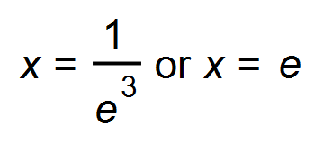 ✓

(ii) 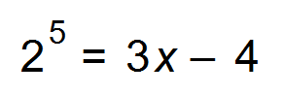 ✓

36 = 3*x*

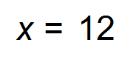 ✓

(b) 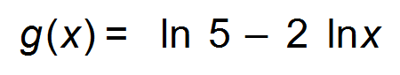 ✓

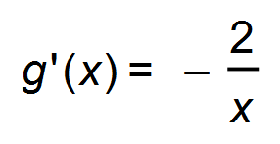 therefore 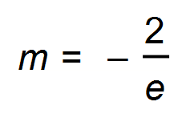 at 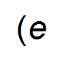,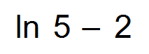) ✓

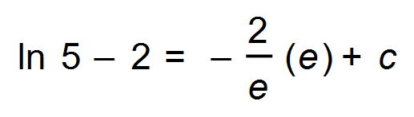

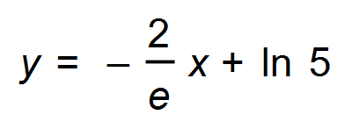 ✓ [8]

5. (a) 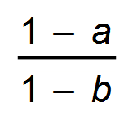 ✓✓

(b) (i) False ✓

In a very large number of samples, 95% of those confidence intervals

would contain *p.* The endpoints of the confidence interval refer to the

confidence and not the probability. *p* is not a random variable and is

either in the CI or not. ✓

(ii) False ✓

The confidence interval is about the population proportion and not

about the individual Australian households ✓

(iii) True ✓

(iv) True ✓ [8]

(the centre of the interval contains the sample proportion)

6. (a) 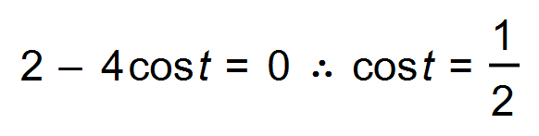

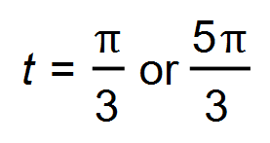 ✓✓

(b) 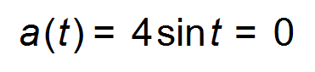

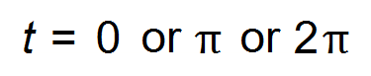 ✓

 ✓

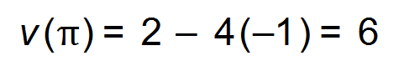

Max velocity is 6m/s ✓

(c) 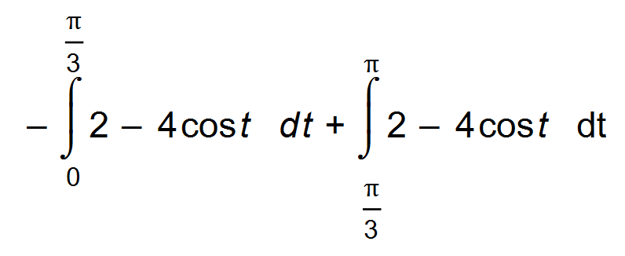 ✓

= + ✓

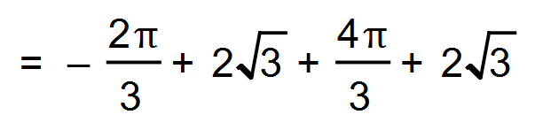 ✓

=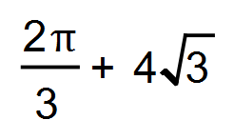 m. ✓ [9]

7. (a) 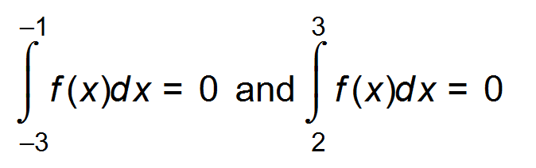

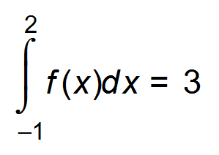 ✓

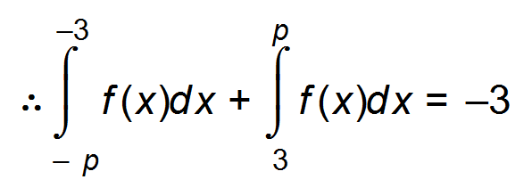 ✓

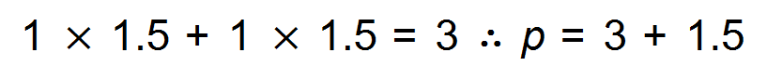

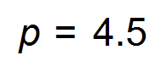 ✓

(b) 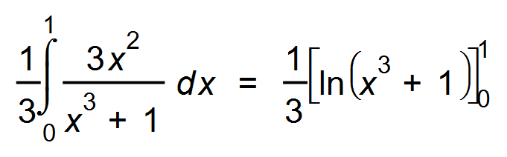 ✓

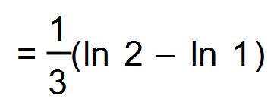 ✓

= 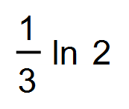 ✓ [6]

8. (a) 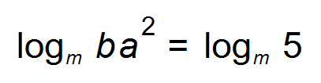 ✓

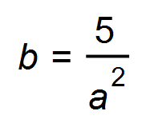 ✓

(b)  ✓

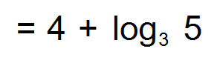 ✓ [4]

9. 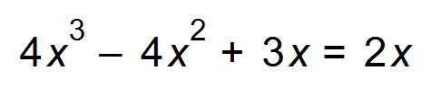

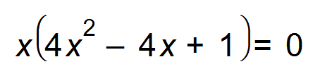

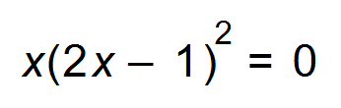

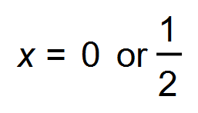 ✓

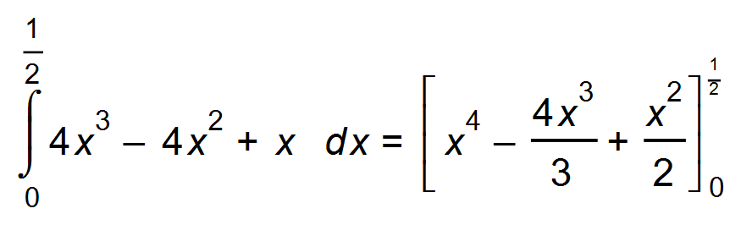 ✓

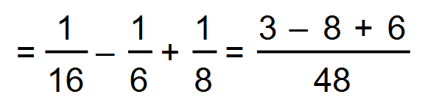 ✓

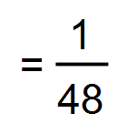 units2  ✓ [4]

***Calculator−assumed Solutions***

10. (a) 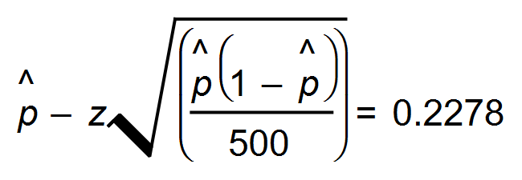and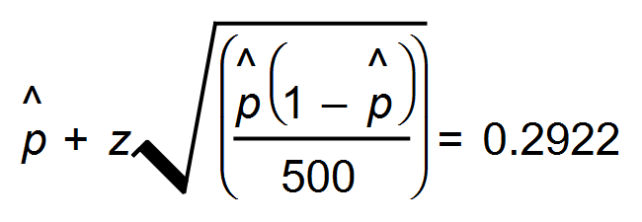✓ 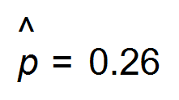 ✓

0.26 of 500 = 130. ✓

(b) *z =* 1.641 Therefore 90 % confidence level. ✓✓ [5]

11. (a) (i) *n* = 20 p = 0.63

P (X ≥ 14) = 0.3453 ✓

(ii) P (X = 20 | X $≥$ 14) = 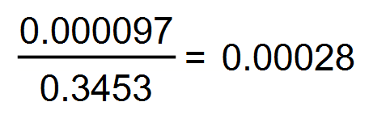 ✓✓

(b) P(X $≥$ 1) $≥$ 0.95

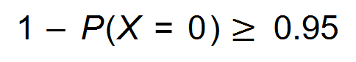

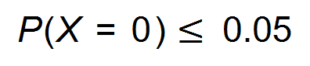 ✓

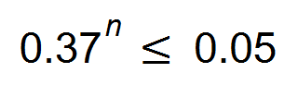 ✓

*n* = 3.01

4 people would need to be selected ✓

(c) E(X)= np

= 300 x 0.63

= 189 ✓

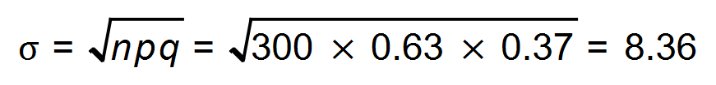 ✓

(d) 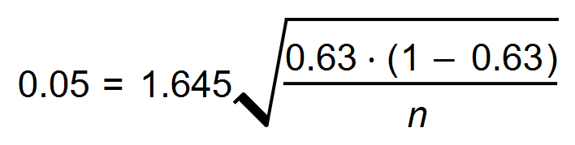 ✓

*n* = 253 credit card holders ✓ [10]

12. 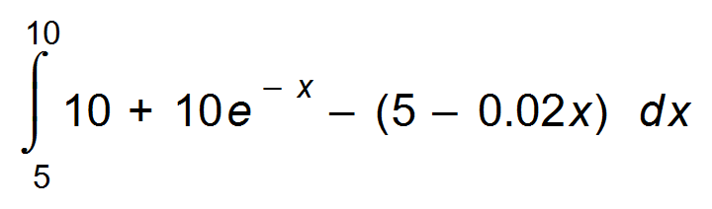 ✓✓

= 25.81693

The profit earned on sales between 500 and 1000 litres is $25.82. ✓ [3]

13. (a) (i) 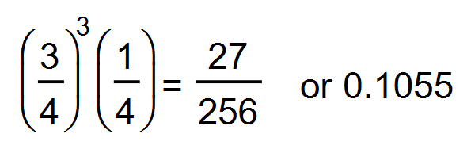 ✓

(ii) 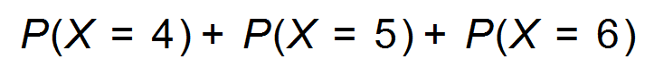 ✓

= 0.1055 + 0.079101 + 0.059326

= 0.243927 ✓

(b) (i) Discrete, independent probability ✓

two outcomes: Success or fail ✓

(ii) E(X) = 0.25 ✓

Standard deviation =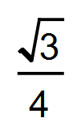 = 0.43301 ✓ [7]

14. (a) 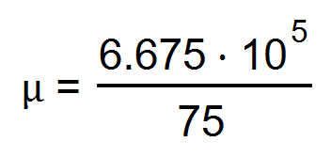 = 8900 litres ✓

(b) Variance = 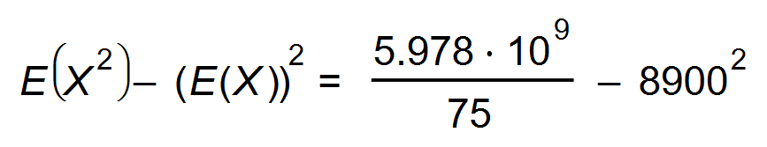

= 496 666.67 ✓

Standard deviation = 704.75 $≈$ 705 litres ✓

(c) P (X ≤ 8550 | 7000 < X < 10 000) = 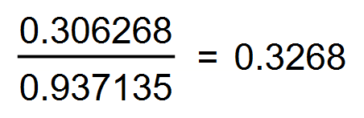 ✓✓

(d) 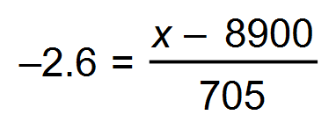 ✓

*x =* 7067 litres

Garage must sell 7068 litres to be profitable ✓ [7]

15. Underestimate: 1 x (0 + 10 + 15 + 11 + 4) = 40 ✓

Over estimate: 1 x (10 + 15 + 16 + 16 + 11) = 68 ✓

Average = 54

Distance is therefore approximately 54 m. ✓ [3]

16. (a) Self-selective sample and therefore not representative of the population. ✓

Only radio listeners were part of the survey, therefore not representative. ✓

(b) Logical answer for example:

a randomly selected sample from the general public is used ✓

(c) 0.03 ✓

(d) 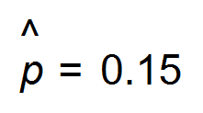Therefore point estimate = 0.15 or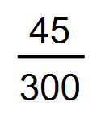 ✓

(e)

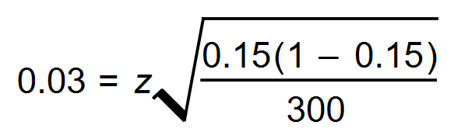 ✓

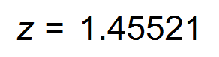 ✓

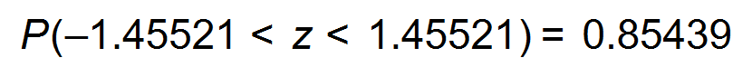

85.4% confidence level ✓ [8]

17. (a) At time *t*, the distance from *B* to *S* is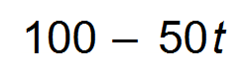. ✓

At time *t*, the distance from *A* to *S* is 80*t.* ✓

Cosine rule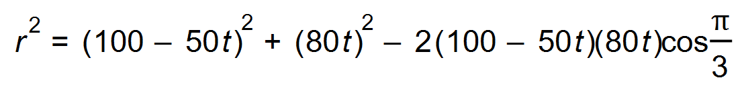 ✓

Therefore 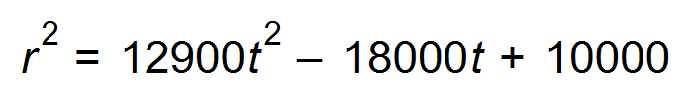

(b) 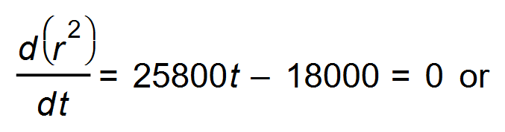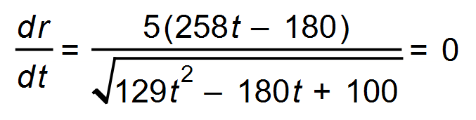✓

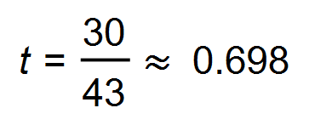 ✓

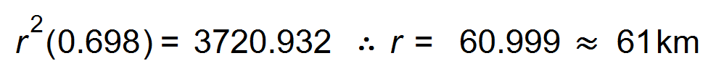 ✓

minimum ✓

The minimum distance is 61 km. [7]

18. (a) 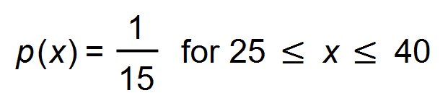 and 0 otherwise ✓

(b) 32.5 min ✓

(c) 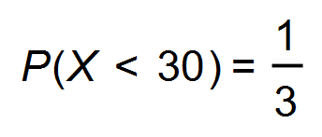 ✓

(d) (i) 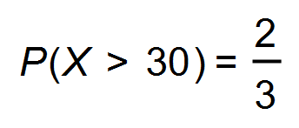 ✓

(ii) 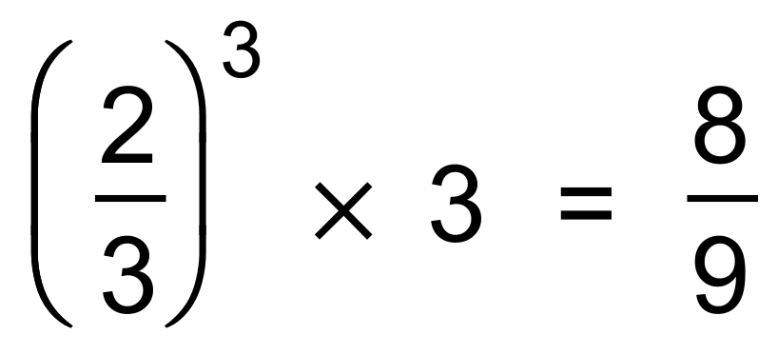 ✓

(e) E(X) = 32.5 Var(X)= 18.75 ✓

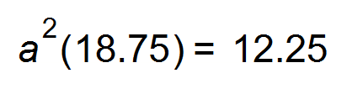 ✓

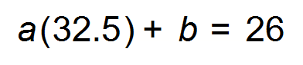 ✓

 ✓ [9]

19. (a) 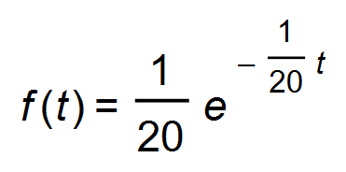 for t > 0 ✓✓

(b) F(20) = 0.6321 ✓

(c) 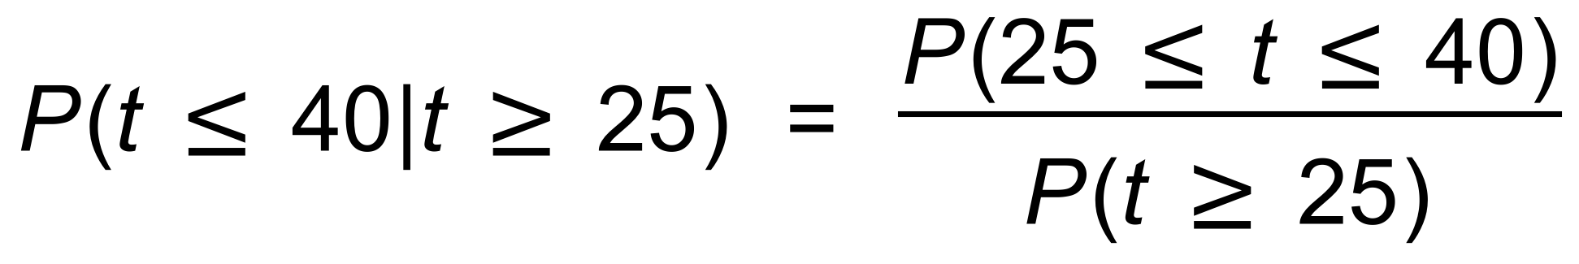

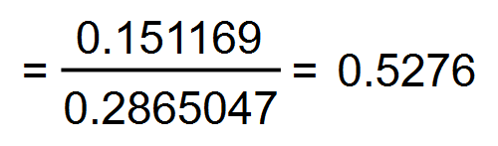 ✓✓

or

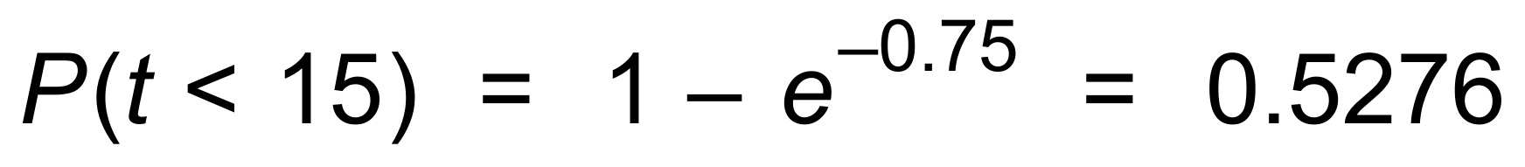

(d) E(*t*) = 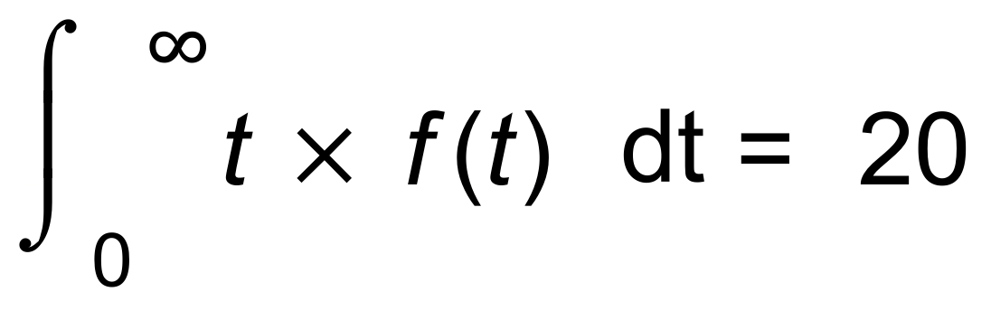

20 months is the mean time (or *k* = 20 = μ) ✓

(e) 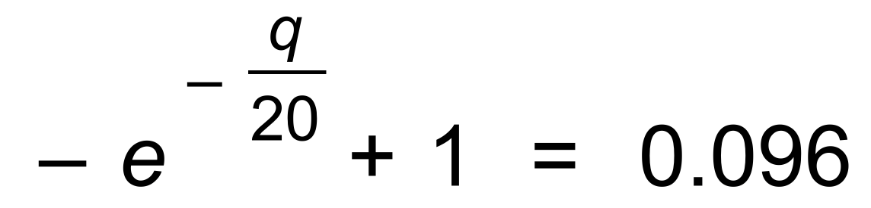

∴ *q* = 2.02 therefore just over 2 months ✓ [7]

20. (a) 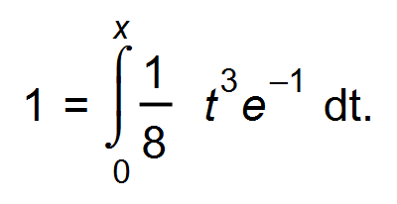 ✓

*x* = 3.0539 ✓

(b) 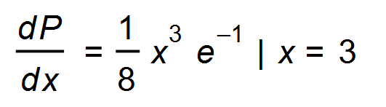 ✓

=1.2416 ✓

(c) 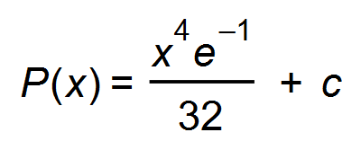

*P*(3) − *P*(1) = 0.93119 – 0.011496 = 0.9197

or 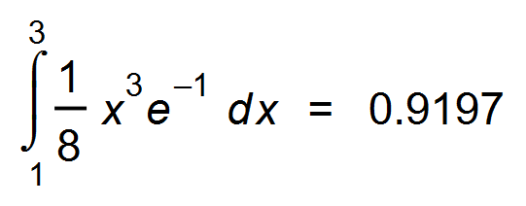 ✓✓

(d) 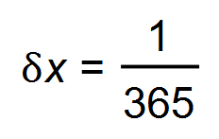 ✓

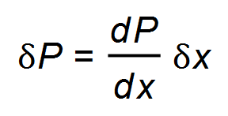

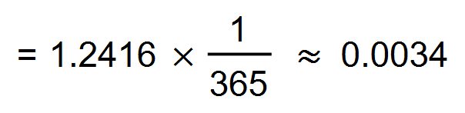 ✓✓ [9]

21. (a) 0.02275 x 3000 = 68.25 ∴ 68 people ✓

(b) (i) $75 538.04 ✓

(ii) B ~ (3, 0.08) ∴ P(X = 1) = 0.2031 ✓✓

(c) New mean = $66 875 ✓

Standard deviation = $7687.50 ✓

(d)  ✓

Therefore 4 interns ✓ [8]

22. (a) 384 carp ✓

(b) 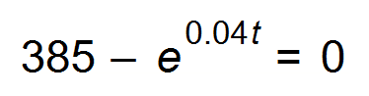

*t* = 148.8 months ✓

In the 149th month

(c) 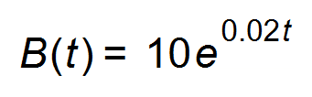 ✓

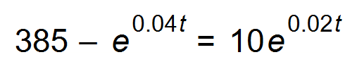 ✓

*t* = 136.2 months after the intro of bass (the 137th month) ✓ [5]

23. (a) 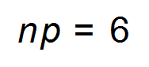Therefore the distribution cannot be determined. ✓

(b) (i) Normal distribution ✓

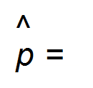N(0.06, 0.013711) ✓✓

(ii) 0.9999 ✓ [5]

24. (a) 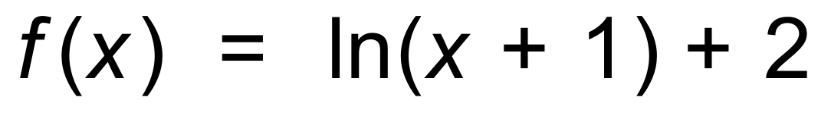 ✓✓

(b) (i) Whisper: I = 1013 W/m2

Conversation: I = 1018 W/m2 ✓

The intensity of the conversation is 105 times ✓

more than the whisper.

(ii) The loudness is an additional 3.0103 dB (10log 2) ✓ [5]